



**Intellectual Property Management Plan**

**February 28, 2011**

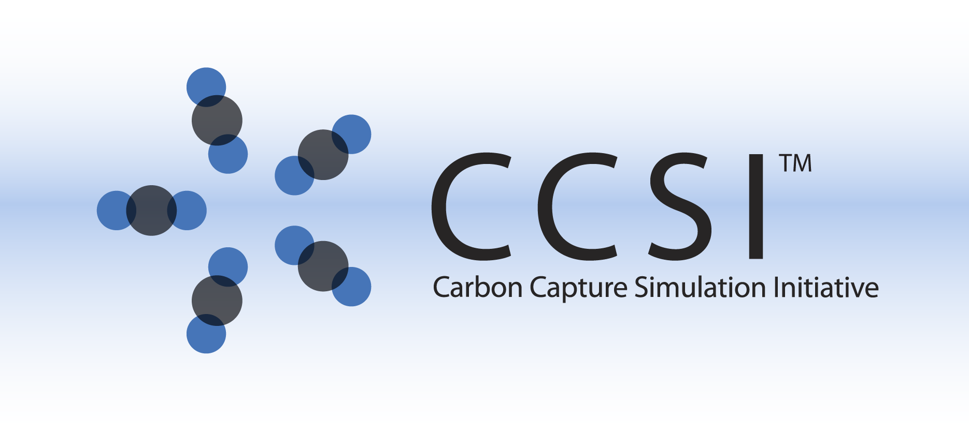

REVEAL-lite INSTALLATION GUIDE

Version 2014.06.24

June 24, 2014

This Material was produced under the DOE Carbon Capture Simulation Initiative (CCSI), and copyright is held by the software owners: ORISE, LANS, LLNS, LBL, PNNL, CMU, WVU, et al. The software owners and/or the U.S. Government retain ownership of all rights in the CCSI software and the copyright and patents subsisting therein. Any distribution or dissemination is governed under the terms and conditions of the CCSI Test and Evaluation License, CCSI Master Non-Disclosure Agreement, and the CCSI Intellectual Property Management Plan. No rights are granted except as expressly recited in one of the aforementioned agreements.

Table of Contents

1. Introduction 1

2. Prerequisites 1

2.1. Hardware 1

2.2. Software 1

3. Basic Installation 2

3.1. Third Party Software Installation 2

3.2. Environment Variables 3

3.3. Product Build ( Optional) 3

3.4. Product Installation 4

4. Installation Test 4

5. Installation Problems 5

5.1. Known Issues/Fixes 5

5.2. Reporting Installation issues 6

# Introduction

REVEAL-lite framework is a toolkit for reduced order modeling of scientific simulations. It has been developed under Carbon Capture Simulation Initiative for response surface generation of Computational Fluid Dynamics(CFD) models using MFIX(Multiphase Flow with Interphase Exchanges) and Barracuda code. However it is a generic framework and can be customized for use in other domains or other models than MFIX/Barracuda.

# Prerequisites

## Hardware

N/A

## Software

REVEAL-lite has been tested on 32 bit and 64 bit windows platform. The framework requires Java Runtime Environment , and certain Python and R libraries. The list of software needed for the install is provided in Table 1.

Note : Users are expected to run their own CFD simulations

|  |  |  |
| --- | --- | --- |
| **Package** | **Online Installation Link** | **Version required** |
| 1. Python | http://python.org/download/ | 2.6 (exact required) |
| 1. Java | Oracle.org | 1.6 or higher |
| 1. R | http://cran.r-project.org/ | R 2.9.1 (exact version required) |
| 1. Numeric | http://numpy.scipy.org/ | Compatible with installed Python version |
| 1. win32all | http://starship.python.net/crew/mhammond/win32/Downloads.html | Pywin32-214.win32-py2.6.exe |
| 1. RPy | http://rpy.sourceforge.net/rpy_download.html | Compatible with installed Python and R versions |
| 1. lhs | http://cran.r-project.org/web/packages/lhs/index.html | Compatible with installed R version |
| 1. rngWELL | <http://cran.r-project.org/web/packages/rngWELL/index.html> | 0.10 |
| 1. randtoolbox | <http://cran.r-project.org/web/packages/randtoolbox/index.html> | 1.10 |

Table 1: Getting Required Packages

# Basic Installation

To use iREVEAL, user needs to have java version 6 (**java -1.6 or higher)** installed on the system. To check if java is installed, open command line and on prompt check for java version, you should get appropriate response listing java version. For e.g.,

* java -version

java version 1.6.x.x <build 1.6.x.x>

Java(SE) TM Runtime Environment

If JDK/JRE is not already installed, please install appropriate 32bit or 64 bit JRE

(download link- http://www.oracle.com/technetwork/java/javase/downloads/index.html)

Add JAVA_HOME to your PATH environment variable thereafter (refer to section 4.2 for adding environment variables).

iREVEAL also requires python, numpy, R and Rpy to be installed on the user’s system. The software packages that have been summarized in Table 1. These packages can be installed from the Required packages directory available with the iREVEAL zip file or from the web link provided in the Table. For correct installation, **please install them in the sequence they are written in the table**.

Note : Please install all packages ( especially R) in a directory where you have permission to read/write/modify. E.g of a valid directory: “C:/Users/UserName/”. Problems have been observed if R is installed under “C:\ProgramFiles” ( see section 5 for detail)

The user should set environment variables as explained in section 3.2 and do package installation checks as mentioned in section 5 before proceeding further. Please note that R version 2.9.1 is required and the software may not work with more recent R versions .

## Third Party Software Installation

User should finish installing packages 1-5 ( ***install in order listed in table***) before installing R packages as described below.

The R packages (LHS, rngWell, randtoolbox) can be installed by:

1. Open installed R GUI.
2. If iREVEAL package contains local zip files for lhs , rngWELL and randtoolbox :
   1. From menu select ‘Packages’ then ‘Install package(s) from local zip file’
   2. Select the lhs.zip file provided with the REVEAL package and press OK.
   3. Similarly perform step 2 and select rngWell.zip package and press OK button
   4. Similarly perform step 2, select randtoolbox.zip package and press OK button. (Please note that rngWELL is pre-requisite for installing randtoolbox package a and hence “rngWELL” must be installed before randtoolbox)
   5. Also, unzip all 3 packages and copy the 3 directories (lhs, rngWELL, randtoolbox) under RHOME/library/ ( Note : This is due to an installation bug in R.2.9.1 where it installs libraries in some other location that RHOME/library/ and is unable to find and load libraries during runtime.

OR

1. Open installed R GUI.
2. Go to “Install Packages” in Menu and install
   1. LHS
   2. rngWELL
   3. randtoolbox

To check if the packages were installed correctly, please refer to section 5.

## Environment Variables

To set up environment variables on Windows: Right click on MyComputer, and select Properties. Under Advanced Tab click ‘Environment Variable’ button.

1. Add following as an environment variable:
   1. RHOME = home directory where R is installed

For e.g., RHOME= C:\Program Files\R\R-2.9.1

* 1. R_LIBS_USER = where R installed the “lhs”, “rngWELL” and “randtoolbox” packages. For e.g

R_LIBS_USER = C:\Users\Username\Documents\R\win-library\2.9\

The directory specified above should contain packages installed “lhs”, “rngWELL” and “randtoolbox”.

1. Add following to PATH variable:
   1. bin folder of R to ‘Path’ environment variable

For e.g., C:\Program Files\R\R-2.9.1\bin\

* 1. Add path to Python home directory also to ‘Path’

For e.g., C:\Python26\

## Product Build ( Optional)

To build iREVEAL jar file directly from source, the user may follow the instructions below or user can download the iREVEAL jar file directly from CCSI product page.

Option 1:

1. Checkout the iREVEAL code from svn:
   1. <https://svn.acceleratecarboncapture.org/svn/projects/iREVEAL/trunk/>
2. to simplify discussion, assuming the directory you checked out code is *$iREVEAL_HOME*
3. Open cmd.exe on windows and ‘cd’ to *$iREVEAL_HOME/iREVEAL*
4. Execute build.bat on command line:
   1. *$iREVEAL_HOME/iREVEAL>build.bat*
   2. And press “Enter”
5. The above step will create a bin directory and a iREVEAL.jar under *$iREVEAL_HOME/iREVEAL*

These steps should create a runnable jar file for iREVEAL project. Please note that if your system cannot find “javac” or “jar” command check you system “$PATH” environment variable and ensure JAVA is installed, JAVA_HOME is defined and JAVA_HOME/bin is added to your $PATH environment variable.

**Alternate option to build jar file using ANT:** If you would like to use ANT to build the jar file from source code, you can do that by using buid.xml file in *$iREVEAL_HOME/iREVEAL directory as follows:*

* Execute build.xml using ant on command line:
  + *$iREVEAL_HOME/iREVEAL>ant*
  + And press “Enter”

This should have the same effect as described above after steps 1-4.

## Product Installation

We recommend installing iREVEAL in user’s home directory. For installing iREVEAL (once all pre-requisites have been installed successfully), all you need to do is unzip the file:

1. unzip iReveal.zip in an empty/new folder

Note : The directory selected here will get populated by bunch of files and folders for iREVEAL, so you might want to select an empty directory. Also, please ensure you have write privileges to directory which you selected.

# Installation Test

To test if all packages were installed successfully, please open command prompt and follow the sequence as shown on the screen capture. (Ensure all the environment variables are setup correctly as described in section 3.2, before doing the installation tests). You should get appropriate version numbers in output:

* python –version

Python 2.6

* R –version

R version 2.9.1

If R and python were installed successfully, you should be able to start R on command prompt and load the libraries by:

* R
* library(“lhs”)
* library(“rngWELL”)
* library(“randtoolbox”)’

The library loading should not generate error messages like library not found. A warning message for randtoolbox and rngWELL being built with R.2.9.2 can be safely ignored. (See attached snapshot)

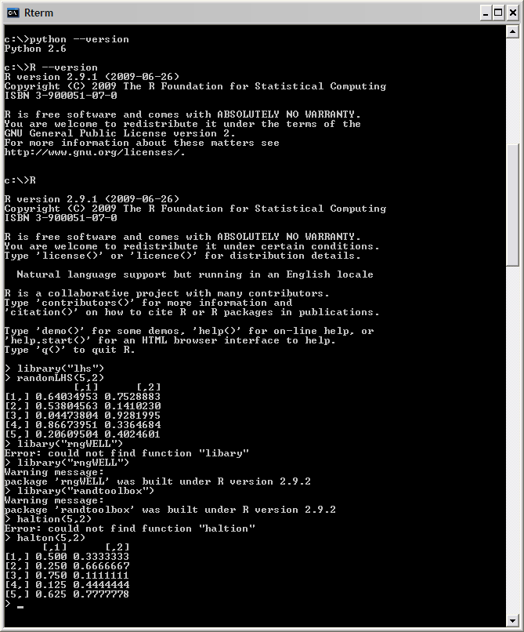

Figure 1: Testing external library installation

If the libraries were installed successfully , please refer to the user manual for further instructions on using the toolkit

# Installation Problems

## Known Issues/Fixes

* If during R package installation , a message pops up asking user if they want to create a separate library for installing R packages => User does not write permission to directory where R is installed.

Solution: Install R in “C:\Users\UserHome” instead of “C:\Program Files”

## Reporting Installation issues

Contact [ccsi-support@acceleratecarboncapture.org](mailto:ccsi-support@acceleratecarboncapture.org).

The email of lead development team for this product are :

[Khushbu.Agarwal@pnnl.gov](mailto:Khushbu.Agarwal@pnnl.gov),

[Poorva.Sharma@pnnl.gov](mailto:Poorva.Sharma@pnnl.gov);

[Jinliang.Ma@netl.gov](mailto:Jinliang.Ma@netl.gov),

[Xin.Sun@pnnl.gov](mailto:Xin.Sun@pnnl.gov),